**Name:** donya khaled elsaeed

**B.N:** 331

**Date**: 2/6/2020

**Topic**: programming languages

**Application brief:**

Modern human life is greatly influenced by computers. And the computer is run by a computer program. Computer programs are arranged by programming languages, therefore they are the basis of all the conveniences that we feel. Programming languages are responsible for all programs that have been made; rostering systems, virtual reality, scheduling software, online games, Uber app, anti-virus and so on. Thus mastering programming languages brings one closer to understanding how all digital technology originates. This article will highlight the importance of programming languages.

Programming languages ​​refer to different types of expressions and logical structuring rules that serve to generate recurring and systematic tasks. They are of great importance because they allow generating different systems that serve tasks that meet the needs of users. There is a great variety of these languages ​​and in any case they are oriented to different types of requirements; however, this plurality can be divided into two large groups, structured programming languages ​​and object-oriented languages. Almost everything we can use in computer science is largely due to programming languages.

Screenshots:

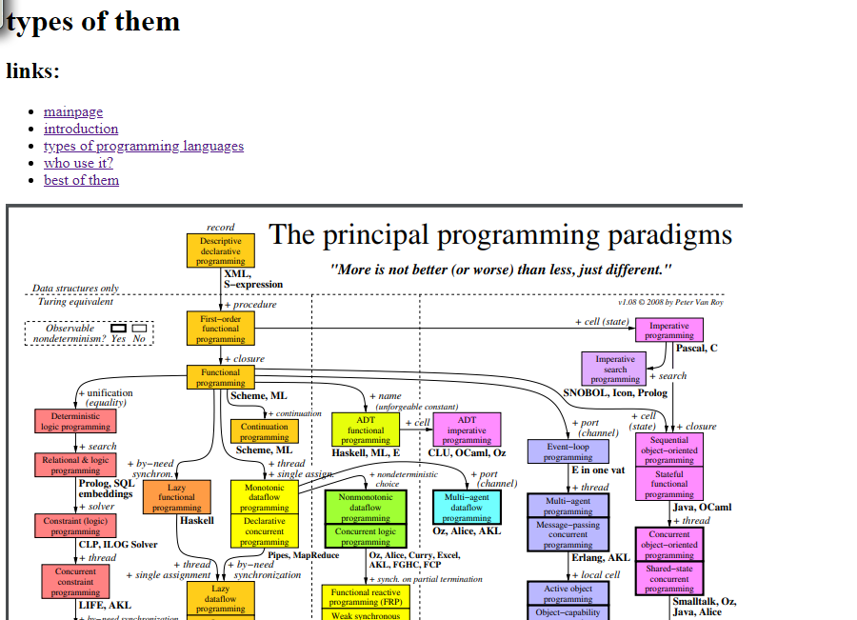

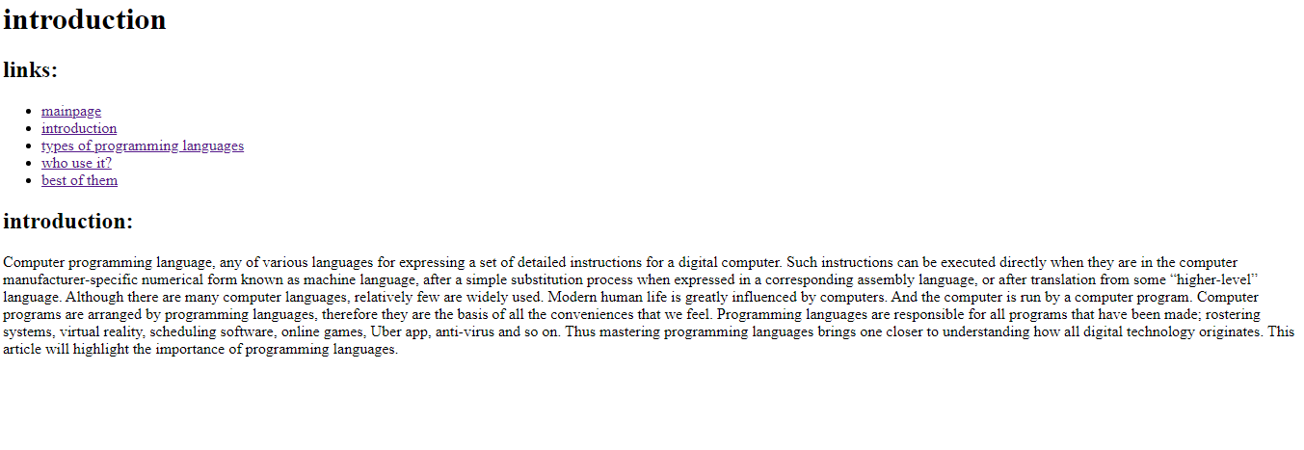

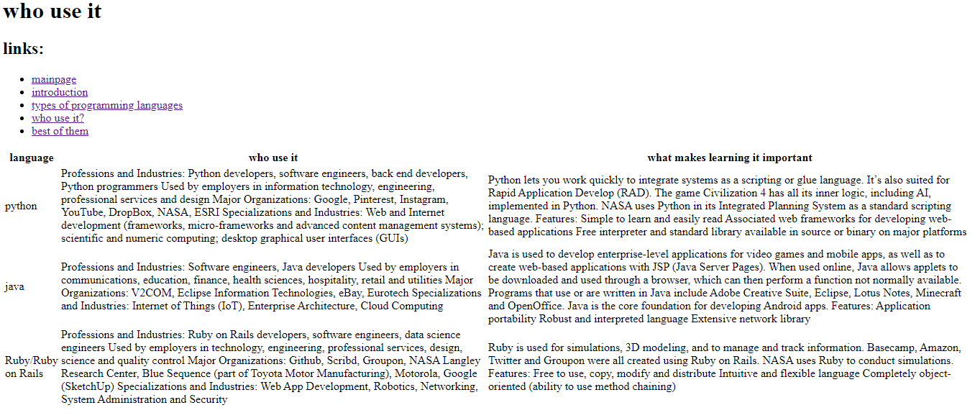

Source code:

